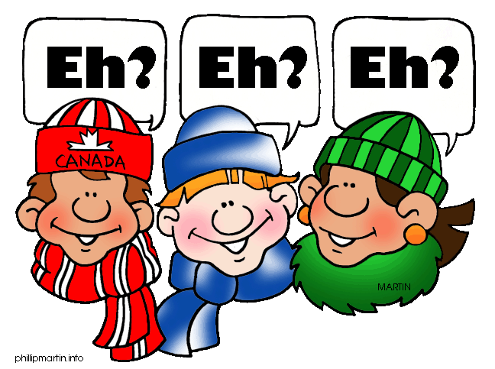

How to write an informal letter

Informal letters are also known as personal letters. They are letters you write to people you know well, like friends and relatives. When you write an informal letter there are a few rules to pay attention to.

In informal letters, you can use all the abbreviations you like. You usually start an informal letter with *Dear* plus the first name of the person you are writing to **Dear John, Dear Aunt Abbey, or Dear Mom** – *followed by a comma*. You can end an informal letter with *Love* (if it’s a close friend or relative). *Remember to follow it with a comma*.

Also remember to include a **date** (i.e; February 28, 2013 / February 28th, 2013)

**FREE WRITING: (CANADA)**

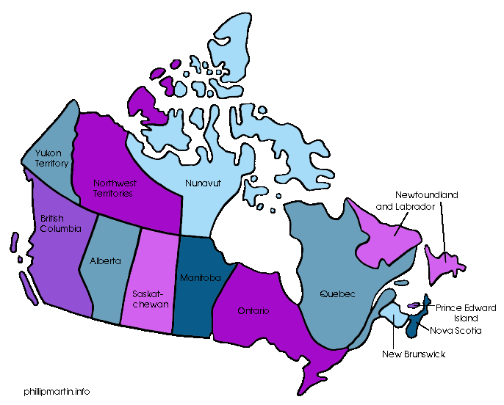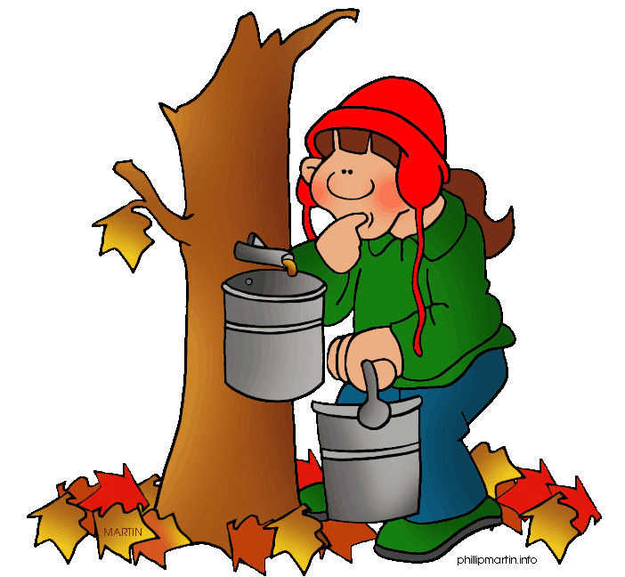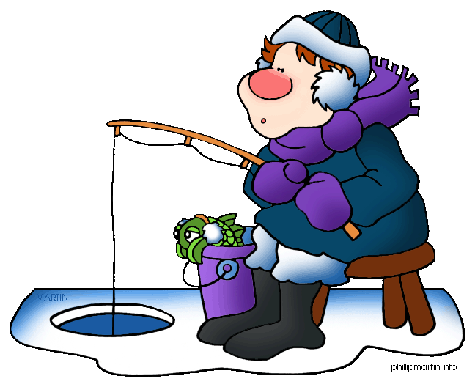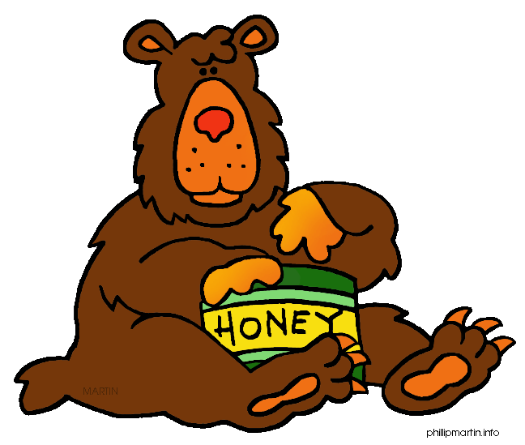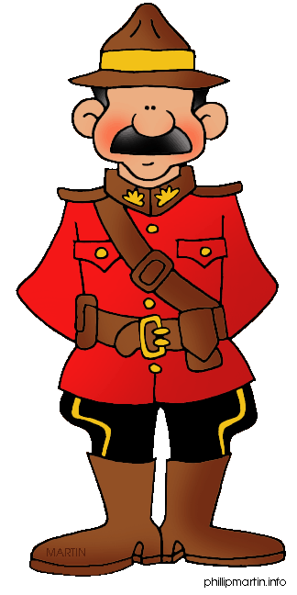

TASK

Imagine you are on a holiday in Canada. You are going to write back to your family or friends telling them about your time away from your home country and your experiences in Canada. You may want to include information about whom you are with, where you have been or are going, about nature, about the weather, about positive and negative aspects of Canadian life style, your itinerary, your journey etc.